

**Group Report – Agile Business Analysis**

# Mortgage transparency for every stakeholder’s happiness

Authors: Anuradha Kishore - Agnes Pakozdi - Tran Ngoc Anh - Gaël Feyertag

Coach: Prof. Dr. Knut Hinkelmann

Inhalt

Mortgage transparency for every stakeholder’s happiness 1

Introduction & Problem Statement 2

One Page – Background information 2

Elicitation and Collaboration 3

requirements lifecycle management 4

Strategy Analysis 5

Requirements Analysis and Design Definition 6

Solution evaluation 7

conclusion 8

## Introduction & Problem Statement

In the application of its module **Business Agile Analysis** (ABA), the Group 9 (AAAG) chose to imagine a scenario where **Money Park**, a leading provider in the brokerage of Mortgage in Switzerland, launches a new project.

Hereafter, Money Park charges a small project team (Group 9) to conduct a **preliminary project work** in an **agile way** on **the complex mortgage ecosystem** to make this business area and topic **easier**, **better understandable** and **more transparent** to increase all stakeholders' happiness.

In this report, the group 9 is dedicated to report the tasks it performed within the described (fictive) project during the three sprints along the Business Analysis Knowledge Areas: **Elicitation and Collaboration**, **Requirements Lifecycle Management**, **Strategy Analysis**, **Requirements Analysis and Design Definition** and **Eventually Solution Evaluation.**

## One Page – Background information

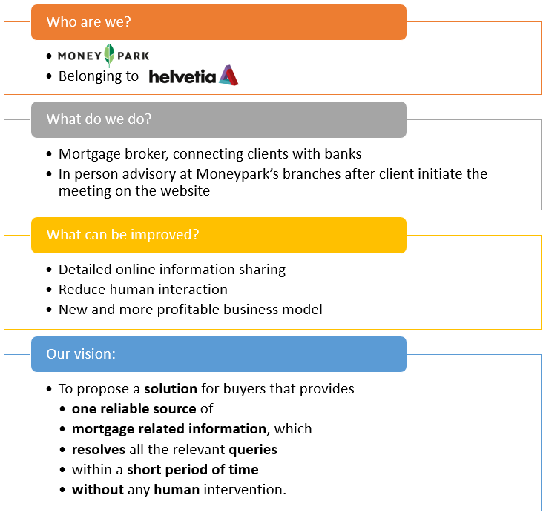

## Elicitation and Collaboration

**Here max. 4 pages on ELICITATION AND COLLABORATION**

## requirements lifecycle management

**Here max. 4 pages on REQUIREMENTS LIFECYCLE MANAGEMENT**

**How did you analyse current state (stakeholder involvement)?**

Stakeholder, as defined in elicitation and collaboration, are

* Current and future mortgage customers
* Our team
* Lecturers and coaches from the ABA class
* Moneypark

**How did you define future state?**

Future state is defined in the vision and evolved through the Sprints.

**How was risk assessment done?**

Firstly with a risk matrix, we anslysed the potential risks, their probablitites to occur, concequences and actions to mitigate risks.

The risk matrix is kept up to date whenever a new risk is identified or a risked is successfully mitigated.

## Strategy Analysis

**Here max. 4 pages on STRATEGY ANALYSIS**

## Requirements Analysis and Design Definition

**Here max. 4 pages on REQUIREMENTS ANALYSIS AND DESIGN DEFINITION**

## Solution evaluation

**Here max. 4 pages on SOLUTION EVALUATION**

## conclusion

We learnt a lot.